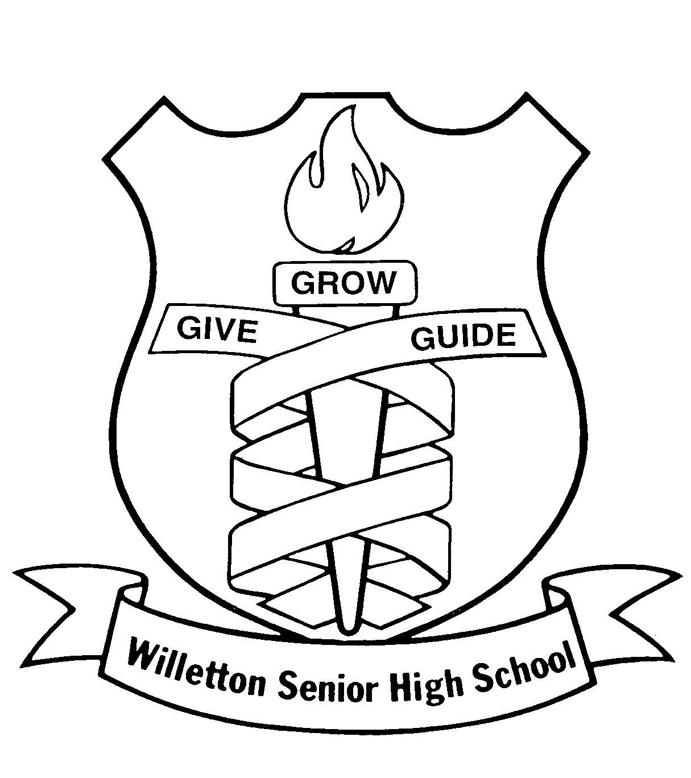**WILLETTON SENIOR HIGH SCHOOL**

**YEAR 12 SEMESTER TWO EXAM, 2021**

**CHEMISTRY**

MULTIPLE CHOICE QUESTION BOOKLET

# Time allowed for this paper

## Reading time before commencing work: ten (10) minutes

Working time: three (3) hours

# Materials required/recommended for this paper

***To be provided by the supervisor:***

This Multiple Choice Question Booklet

Multiple-choice Answer Sheet & Question/Answer Booklet

Chemistry Data Book

***To be provided by the candidate:***

Standard items: pens (blue/black preferred), pencils (including coloured), sharpener,

eraser, correction tape/fluid, ruler, highlighters

Special items: up to three calculators, which do not have the capacity to create or store programmes or text, are permitted in this ATAR course examination

# Important note to candidates

No other items may be taken into the examination room. It is **your** responsibility to ensure that you do not have any unauthorised material. If you have any unauthorised material with you, hand it to the supervisor **before** reading any further.

**Structure of this paper**

|  |  |  |  |  |  |
| --- | --- | --- | --- | --- | --- |
| Section | Number of questions available | Number of questions to be answered | Suggested working time  (minutes) | Marks available | Percentage of exam |
| Section One:  Multiple-choice | 25 | 25 | 50 | / 50 | / 26 |
| Section Two:  Short answer | 9 | 9 | 60 | / 69 | / 36 |
| Section Three:  Extended answer | 5 | 5 | 70 | / 71 | / 3 |
| 190 | | | | | / 100 |

**Instructions to candidates**

1. Answer the questions according to the following instructions.

Section One: Answer all questions on the separate Multiple-choice Answer Sheet provided. For each question shade the box to indicate your answer. Use only a blue or black pen to shade the boxes. If you make a mistake, place a cross through that square then shade your new answer. Do not erase or use correction fluid/tape. Marks will not be deducted for incorrect answers. No marks will be given if more than one answer is completed for any question.

Sections Two and Three: Write your answers in this Question/Answer Booklet.

2. When calculating numerical answers, show your working or reasoning clearly. Express numerical answers to the appropriate number of significant figures and include appropriate units where applicable.

3. You must be careful to confine your responses to the specific questions asked and to follow any instructions that are specific to a particular question.

4. Spare pages are included at the end of this booklet. They can be used for planning your responses and/or as additional space if required to continue an answer.

* + Planning: If you use the spare pages for planning, indicate this clearly at the top of the page.
  + Continuing an answer: If you need to use the space to continue an answer, indicate in the original answer space where the answer is continued, i.e. give the page number. Fill in the number of the question(s) that you are continuing to answer at the top of the page.

5. The Chemistry Data Book is **not** handed in with your Question/Answer Booklet.

**Section One: Multiple-choice 26% (50 marks)**

This section has **25** questions. Answer **all** questions on the separate Multiple-choice Answer Sheet provided. For each question, shade the box to indicate your answer. Use only a blue or black pen to shade the boxes. If you make a mistake, place a cross through that square then shade your new answer. Do not erase or use correction fluid/tape. Marks will not be deducted for incorrect answers. No marks will be given if more than one answer is completed for any question.

Suggested working time: 50 minutes.

1. Consider a chemical reaction with the following characteristics.

1. The reaction is exothermic.
2. The reaction occurs spontaneously at room temperature.
3. The reaction is very difficult to reverse.

Which energy profile diagram most accurately represents this reaction? Assume the scale on each set of axes is identical.

1. (b)

Reaction progress

Enthalpy

Reaction progress

Enthalpy

1. (d)

Reaction progress

Enthalpy

Reaction progress

Enthalpy

2. Which of the following ranks the compounds in order of increasing oxidation state for chlorine?

1. NH4Cl HClO3 Cl2O7
2. HClO3 Cl2O7 NH4Cl
3. Cl2O7 HClO3 NH4Cl
4. NH4Cl Cl2O7 HClO3

3. Consider the following organic compound.



The correct IUPAC name for this substance is

1. 1-amino-4-chloro-3-ethylhexanal.
2. 4-chloro-3-ethylhexanamide.
3. 3-ethyl-4-chlorohexanamide.
4. 1-amino-3-ethyl-4-chlorohexanal.

A sample of liquid dinitrogen trioxide, N2O3, is placed in a sealed glass tube where the temperature of the system is maintained at -15 °C. The N2O3 begins to decompose and eventually establishes equilibrium, as shown in the chemical equation below.

N2O3(l) ⇌ NO(g) + NO2(g)

The following rate graph illustrates the establishment of equilibrium in this system at Time E1.

reaction rate

forward

reverse

l

E1 Time

4. Which of the following statements is **not** correct?

(a) Before Time E1, the forward reaction rate is decreasing.

(b) Before Time E1, the forward reaction rate is faster than the reverse reaction rate.

(c) At Time E1, the forward and reverse reaction rates both become zero.

(d) At Time E1, the forward and reverse reaction rates become equal.

5. To protect an underground steel pipe, a DC power supply is used. Which one of the following statements about this procedure is **not** correct?

1. This procedure is called “cathodic protection”
2. The steel pipe is held at a positive potential to prevent its corrosion
3. The negative terminal of the battery is connected to the cathode.
4. A sacrificial anode acts as the reducing agent

6. Three separate test tubes contain three different 0.5 mol L-1 aqueous salts. Several drops of universal indicator were added to each test tube; one turned pink, one turned green and one turned blue.

Which of the following lists three solutions that would produce these observations?

**Red green blue**

1. KNO3 Na2SO4 CaCO3
2. K2CO3 KCl LiF
3. NH4Cl Mg(NO3)2 K2CO3
4. LiHCO3 CaF2 BaCl2

7. A piece of silver-coloured metal was placed into a beaker containing nickel chloride solution. Over time, the green colour of the solution faded. The identity of the metal is

1. silver.
2. cobalt.
3. tin.
4. zinc.

8. Consider the segment of polypeptide shown below.



Bonds contributing to the secondary structure of this protein could form between sites

1. A and C.
2. B and F.
3. A and E.
4. D and F.

**Questions 9 and 10 refer to the following equilibrium system.**

Consider the following chemical reaction that has been allowed to establish equilibrium in a closed system.

Cl2(g) + F2(g) ⇌ 2 ClF(g) + 113 kJ

Two different changes were imposed on the system at Time T1 and T2. In each case the system was allowed to re-establish equilibrium. The graph below illustrates the changes that occurred in the system.

Partial pressure (kPa)

l l l l

T1 E1 T2 E2 Time

ClF(g)

F2(g)

Cl2(g)

9. Identify the changes imposed on the system at Times T1 and T2.

**T1 T2**

1. Increased volume Increased temperature
2. Increased volume Decreased temperature
3. Decreased volume Increased temperature
4. Decreased volume Decreased temperature

10. Compare the rate of forward reaction and the value of the equilibrium constant at Time E1 and Time E2. Which of the following correctly describes these characteristics at Time E2?

**Rate of forward reaction Value of Kc**

1. Higher than E1 Higher than E1
2. Higher than E1 Lower than E1
3. Lower than E1 Higher than E1
4. Lower than E1 Lower than E1

11. Which of the following are weak, monoprotic acids?

1. CH3COOH(aq)
2. HF(aq)
3. H2C2O4(aq)
4. HCl(aq)
5. NH3(aq)
6. (i) and (ii) only.
7. (ii) and (iv) only.
8. (i) and (v) only.
9. (iii) and (iv) only.

12. Consider the reaction represented by the chemical equation below.

2 Cu(CN)32-(aq) + 6 H+(aq) + S2-(aq) ⇌ Cu2S(s) + 6 HCN(aq)

The equilibrium constant expression for this reaction is

[Cu(CN)32-]2 [H+]6 [S2-]

[HCN]6

[Cu2S] [HCN]6

[Cu(CN)32-]2 [H+]6 [S2-]

[HCN]6

[Cu(CN)3]2- [H]+ [S]2-

[HCN]6

[Cu(CN)32-]2 [H+]6 [S2-]

K =

K =

K =

K =



13. Consider the industrial conditions used in the Haber process during the manufacture of ammonia. In which of the following conditions are BOTH reaction rates and equilibrium yield not favourable for the synthesis of ammonia?

1. High concentration of reactants.
2. High pressure.
3. High temperature.
4. Addition of an Fe3O4 catalyst.

14. Which one of the following is the strongest reducing agent?

(a) F2(g)

(b) F-(aq)

(c) K+(aq)

(d) K(s)

15. The following chemical equation represents the autoionisation of water.

2 H2O(l) + heat ⇌ H3O+(aq) + OH-(aq)

As a sample of pure water is cooled from 25 °C to 4 °C, the

1. concentration of H3O+(aq) increases.
2. concentration of OH-(aq) increases.
3. pH increases.

(d) value of Kw increases.

16. Consider the incomplete series of equations below, representing the chemical reactions occurring in the Contact process.

S(l) + O2(g) → **X**(g)

**X**(g) + O2(g) ⇌ **Y**(g)

**Y**(g) + H2SO4(l) → **Z**(l)

**Z**(l) + H2O(l) → 2 H2SO4(aq)

Identify the substances represented by X, Y and Z.

**X Y Z**

1. SO2 SO3 H2S2O7
2. SO3 S7O2 H2SO4
3. SO2 SO3 H2SO4
4. SO3 S7O2 H2S2O7

**Questions 17 and 18 refer to atmospheric carbon dioxide levels.**

An increased level of atmospheric CO2(g) is resulting in various negative environmental consequences.

17. Which of the following environmental impacts is **not** caused by an increase in atmospheric CO2(g)?

1. Deforestation.
2. Global warming.
3. Ocean acidification.
4. Rising sea levels.

Due to the Covid-19 pandemic, the level of global CO2(g) emissions was reduced by 6% in 2020.

18. Which of the following sources of CO2(g) is **least** likely to have contributed to this fall in CO2(g) emissions?

1. The aviation industry.
2. Cars, trucks and other vehicles.
3. Commercial electricity generation.
4. Residential electricity generation.

19. The diagram below represents the molecular structure of a segment of the polymer named poly-3-hydroxyvalerate (PHV).



Identify the PHV monomer(s).





20. The chemical equation below shows the combustion of butane in a limited oxygen supply.

C4H10(l) + 4 O2(g) → 3 CO(g) + C(s) + 5 H2O(g)

Identify the correct statement.

1. Carbon atoms are oxidised.
2. Carbon atoms are reduced.
3. Carbon atoms are oxidised and reduced.
4. Oxygen atoms are oxidised.

**Questions 21 and 22 refer to the galvanic cell below.**

The following cell was set up under standard conditions.

V

Cu(NO3)2(aq)

Cu

Pb

Pb(NO3)2(aq)

**X**

**Y**

21. Correctly identify X and Y, as labelled in the diagram above.

**X Y**

1. anode anion movement
2. anode cation movement
3. cathode anion movement
4. cathode cation movement

22. Which of the following changes to the cell above, would result in a greater EMF being produced? Assume all other conditions stay the same.

(a) Change the Pb/Pb2+ half-cell to Ag/Ag+.

(b) Change the Cu/Cu2+ half-cell to Fe/Fe2+.

(c) Change the Cu/Cu2+ half-cell to Cr/Cr3+.

(d) Change the Cu/Cu2+ half-cell to Co/Co2+.

23. When compared to high density polyethene, low density polyethene has

1. a higher melting point.
2. lower tensile (stretching) strength.
3. stronger dispersion forces.
4. lower transparency.

24. Identify the conjugate base of glutamic acid.





25. Which of the amino acids below would have the highest melting point?

(a) Alanine.

(b) Glycine.

(c) Leucine.

(d) Valine.

**End of Section One**